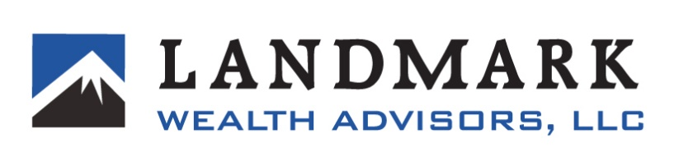
April 10, 2024
Landmark Wealth Advisors, LLC takes precautions to maintain the privacy of personal information concerning its clients. These precautions include the adoption of certain procedures designed to maintain and secure such clients’ nonpublic personal information from inappropriate disclosure to third parties. Federal regulations require Landmark Wealth Advisors, LLC to inform clients of this privacy policy. Landmark Wealth Advisors, LLC collects nonpublic personal information about its clients from the following sources:
• Information from custodian forms, other internal forms, and questionnaires, as well as other communications with clients about potential investment opportunities.
• Information received during a client’s relationship with Landmark Wealth Advisors, LLC.
• Information about transactions within the managed accounts.
Landmark Wealth Advisors, LLC does not disclose any nonpublic personal information about its prospective, existing, or former clients or investors to anyone, except as permitted by law and regulation.
Landmark Wealth Advisors, LLC restricts access to nonpublic personal information about its clients to those employees and agents of Landmark Wealth Advisors, LLC who need to know that information in order to provide services to its clients. Landmark Wealth Advisors, LLC may also disclose such information to its affiliates and to service providers and financial institutions that provide services to clients. Landmark Wealth Advisors, LLC will require such third-party service providers and financial institutions to protect the confidentiality of the client’s nonpublic personal information and to use the information only for purposes for which it is disclosed to them. Landmark Wealth Advisors, LLC maintains physical, electronic, and procedural safeguards that comply with federal standards to safeguard the client’s nonpublic personal information and which Landmark Wealth Advisors, LLC believes are adequate to prevent unauthorized disclosure of such information.
If you have any questions concerning this privacy policy, please contact us at 801-295-8700.

